Project Portal:

Task 2

Daniel Card

CSCE470 – Capstone Project

Adriano Cavalcanti

February 23, 2015

Supervisor:

Dr. Kenrick Mock

kenrick@uaa.alaska.edu

Contents

**1**

**System Integration and Modeling/Methodology** 1

**2.1 Introduction** 1

**2.2 Application** 2

**2.3 Motivation** 5

**2.4 Recent Developments** 6

**2.5 Licensing** 7

**References** 9

**Appendix A** A-1

**Appendix B** B-1

Chapter 2

# **System Integration and Modeling/Methodology**

## **2.1 System Model**

Web applications, or "web apps", are software programs that run on a web server. They consist of diverse components including traditional and nontraditional software, interpreted scripting languages, plain hypertext markup language (HTML) files, mixtures of HTML and programs, databases, graphical images, and complex user interfaces. [1] A web application is available anywhere a connection to the internet is found. This means a web application is not tied to a specific computer like a traditional software application, allowing for more accessibility and ease of use. The user experience tends to be more consistent with a web application, because user data is processed and stored on the server and the graphical user interface (GUI) is dependent on the web browser.

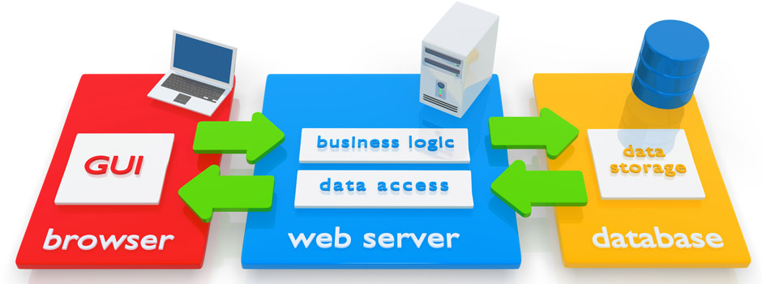

Figure 1.1 - Simple Web Application Diagram by vTech Solution Inc.

The tremendous reach of Web applications into all areas of communication and commerce makes this one of the largest and most important parts of the software industry. [1] Many software companies now offer both desktop and web versions of their most popular programs. Common examples include Microsoft Office, Apple iWork, and Intuit TurboTax. In most cases, files saved in the online version are compatible with the desktop version and vice versa. For example, if you save a .TAX2013 file in TurboTax Online, you can open and edit the file with the desktop version. [2]

## **2.2 Technology**

For my project, I decided to create a web application. My application will be a project portal for teams working on various projects at the Department of Natural Resources (DNR). Each project will have its own project portal and will consist of three main pages. One page will have a map of the project area and the map will have the ability to change which layers are visible to the user. Another page will have a calendar object that will contain the project related activities and meetings. The final page will contain a file browsing object that will display a file location on the server that holds project related files.

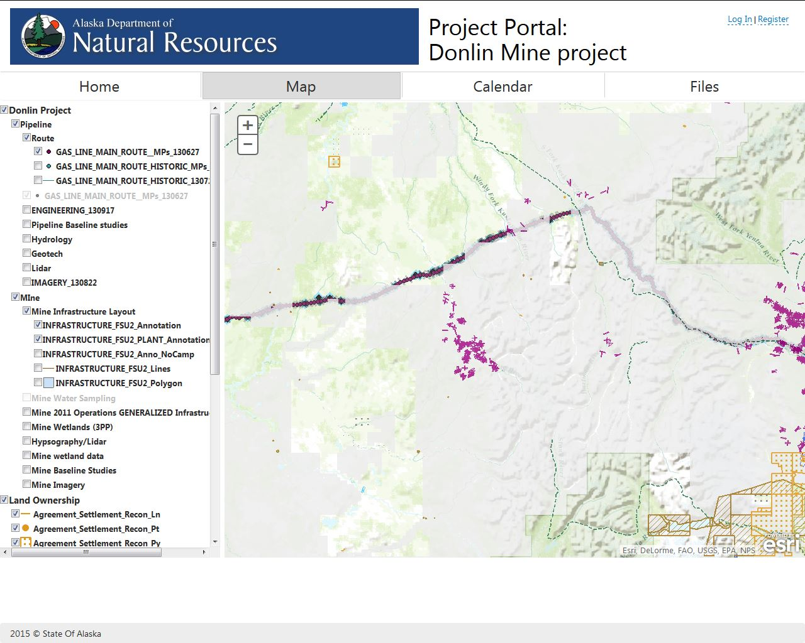

Figure 1.2 – Sample Image of What Maps Page Would Look Like.

A web application can be created using a number of different languages and technologies. The project portal will be primarily built using ASP.NET and C# for server side code. HTML and JavaScript will be utilized to perform client side page rendering services. The file browser and calendar will use third-party libraries from DevExpress.

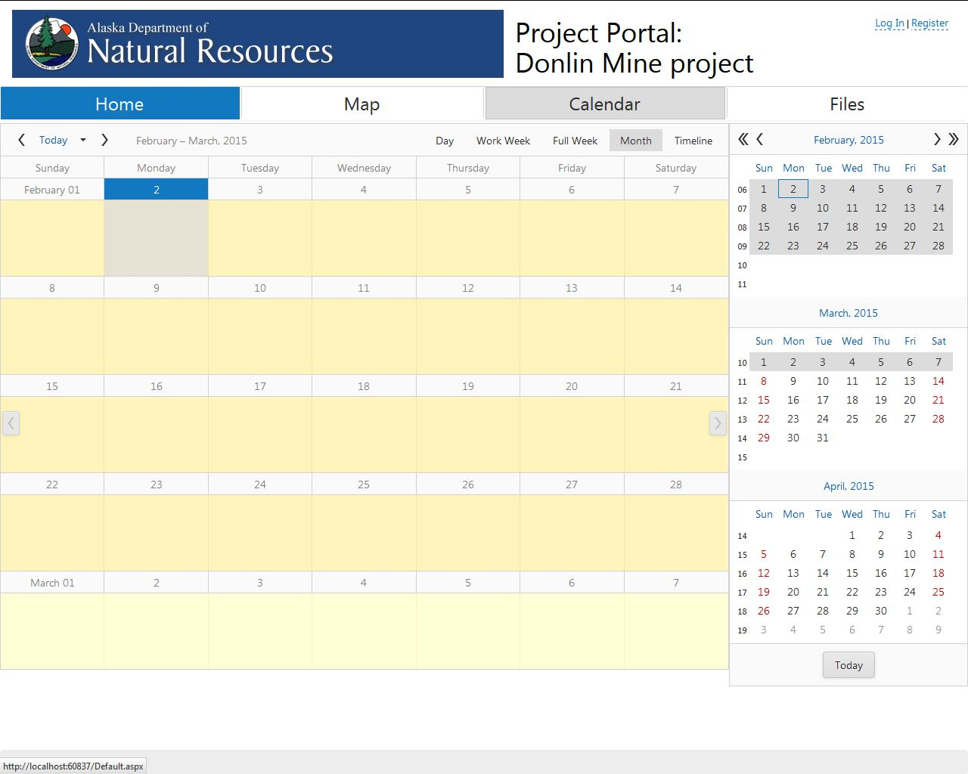

Figure 1.3 – Sample Image of What Calendar Page Would Look Like.

Security requirements can be summarized in two sentences:

* Information should be disclosed only to those meant to see it.
* Actions should be performed only by those authorized to perform them.

Sound simple? So why, with such straightforward goals, is network security deemed one of the tougher areas of computer science? The difficulty lies in the very nature of the goals we’ve defined. While other areas of computer science aim to enable a certain feature, security is the art of prohibiting unauthorized individuals from reaching beyond the permissions they have been granted. All possible attacks must be considered, analyzed, and prevented. [3] The project portal will utilize user login authentication to provide a minimum level of security. This could be upgraded in the future to use the lightweight directory access protocol (LDAP) user credentials that already exist within the State of Alaska system.

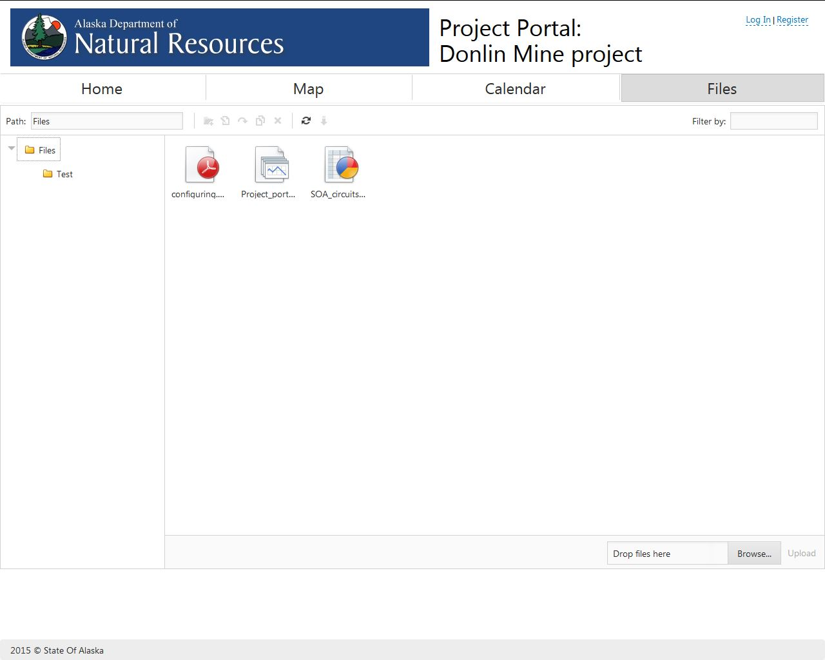

Figure 1.4 – Sample Image of What Files Page Would Look Like.

In Anchorage, .NET is the preferred language for websites and web applications.According to GeoNorth, an Anchorage software development company: “.NET is one of the development languages of choice for high usage sites and sites with complex business rules and workflows.  Because it is a compiled language, it can be many times faster than PHP, ColdFusion, or other languages. You may have also heard of ASP.NET, which is the 'web design' portion of .NET, and works in conjunction with C# or VB.NET. If you want a fast site that can scale, or if you have complex business rules that need a lot of CPU power behind them, .NET is the way to go. Many of our Anchorage clients in Alaska use .NET, and we have deployed enterprise solutions as well as small websites and even handheld applications.” [4]

## **2.3 Motivation**

My primary motivation for this project comes from the fact that I am currently employed at DNR and my department manager asked me if I wanted to do this project. I really wanted to do a project that was going to be very practical and this project allows me to do just that. The project portal is likely to be implemented within the DNR system shortly after its completion and thorough testing. Working with DNR on this project gives me greater access to resources and a knowledge base that would not be available to me otherwise. Doing this project for DNR also gives me the opportunity to work on the project while at work, allowing me to better use my time.

My secondary motivation for wanting to do this project was because my department manager wanted the project done in .NET. I have not used .NET before and am unfamiliar with its features. .NET seems to be used almost exclusively here in Anchorage. Therefore it was important to me to learn how to use it in order to increase my job marketability. Creating web applications is one of the things I am interested in doing for a job, thus being able to put a project like this within my portfolio was very compelling for me.

## **2.4 Recent Developments**

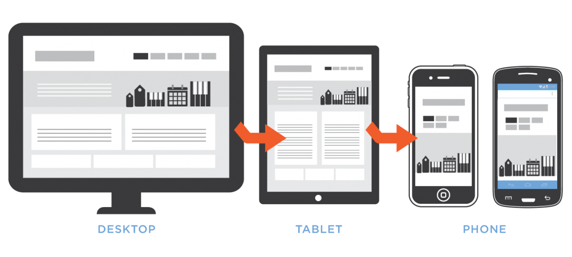

Figure 1.5 – Mobile web development diagram from Techworldsoft.com

The web development sector is always changing an updating with the invention of new technology. The biggest recent change in the web application development area is the addition of mobile computing. Mobile computing presents several challenges for traditional web developers including higher latency wireless networks, small memories, and smaller screen sizes. Mobile devices force web developers to think about things they have never had to think about before. Web applications must now take into account the type of device being used to determine the best experience for the user. Mobile devices with high-latency connections, slower CPUs, and less memory need to be catered to just as much as desktops with wired connections, fast CPUs, and almost endless memory. Web developers now more than ever need to pay close attention to how they craft interfaces, given these constraints. Byte counts, request counts, memory usage, and execution time all need to be considerations as web development for mobile devices continues to evolve. [5]

## **2.5 Licensing**

Project Portal will use a BSD 3-clause license. This will allow me to limit my liability and the State of Alaska’s liability. It also makes it clear than no warranty is provided and that names referenced within cannot be used for promoting a new product containing the code. The code for Project Portal will be completely open source, however databases and files accessed by the code may contain proprietary data. DNR has requested that when source code is shown that references to server names be removed for security reasons.

Copyright (c) 2015, Daniel Card, State of Alaska

All rights reserved.

Redistribution and use in source and binary forms, with or without modification, are permitted provided that the following conditions are met:

1. Redistributions of source code must retain the above copyright notice, this list of conditions and the following disclaimer.

2. Redistributions in binary form must reproduce the above copyright notice, this list of conditions and the following disclaimer in the documentation and/or other materials provided with the distribution.

3. Neither the name of the copyright holder nor the names of its contributors may be used to endorse or promote products derived from this software without specific prior written permission.

THIS SOFTWARE IS PROVIDED BY THE COPYRIGHT HOLDERS AND CONTRIBUTORS "AS IS" AND ANY EXPRESS OR IMPLIED WARRANTIES, INCLUDING, BUT NOT LIMITED TO, THE IMPLIED WARRANTIES OF MERCHANTABILITY AND FITNESS FOR A PARTICULAR PURPOSE ARE DISCLAIMED. IN NO EVENT SHALL THE COPYRIGHT HOLDER OR CONTRIBUTORS BE LIABLE FOR ANY DIRECT, INDIRECT, INCIDENTAL, SPECIAL, EXEMPLARY, OR CONSEQUENTIAL DAMAGES (INCLUDING, BUT NOT LIMITED TO, PROCUREMENT OF SUBSTITUTE GOODS OR SERVICES; LOSS OF USE, DATA, OR PROFITS; OR BUSINESS INTERRUPTION) HOWEVER CAUSED AND ON ANY THEORY OF LIABILITY, WHETHER IN CONTRACT, STRICT LIABILITY, OR TORT (INCLUDING NEGLIGENCE OR OTHERWISE) ARISING IN ANY WAY OUT OF THE USE OF THIS SOFTWARE, EVEN IF ADVISED OF THE POSSIBILITY OF SUCH DAMAGE.

# **References**

|  |  |
| --- | --- |
| [1] | J. Offutt, "Quality Attributes of Web Software Applications," *IEEE Software,* pp. 25-32, 2002. |
| [2] | P. Christensson, "Web Application Definition," 17 February 2014. [Online]. Available: http://techterms.com/definition/web_application. [Accessed 30 January 2015]. |
| [3] | B. Adida, "Securing The Web," *IEEE Internet Computing,* vol. 1, no. 4, pp. 91-93, 1997. |
| [4] | GeoNorth, ".Net Development in Anchorage," GeoNorth, [Online]. Available: http://www.geonorth.com/development/net/anchorage. [Accessed 2 February 2015]. |
| [5] | N. C. Zakas, "The Evolution of Web Development for Mobile Devices," *ACM Queue,* vol. 11, no. 2, pp. 1-10, 2013. |



For project code please see:

https://github.com/YukonJack777/CSCE470-Capstone/tree/master/projectsuite